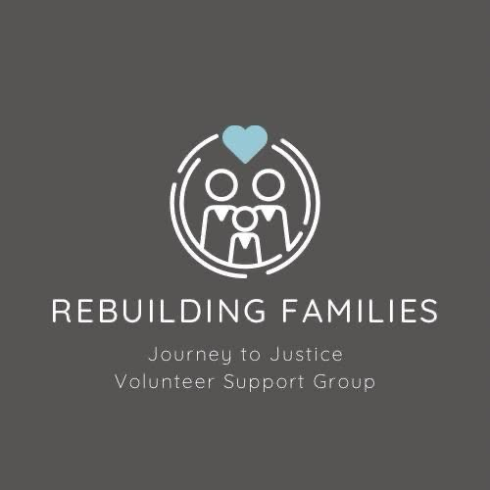
Whistleblower Procedure
Rebuilding Families: Journey to Justice
Note: Whilst the support group is establishing the organisation, the main contacts for reporting any incidents or concerns are either Carrie or Sharon.

1. Purpose of the Procedure
This procedure outlines the steps to be taken when a volunteer or individual raises a whistleblowing concern, in line with our Whistleblower Policy. It ensures that concerns are treated seriously, investigated appropriately, and managed with respect for confidentiality and fairness.

2. Who Can Use This Procedure
• Any volunteer involved with Rebuilding Families: Journey to Justice
• Anyone working in collaboration with the organisation (e.g., partner groups or funders)
• Members of the public who have a legitimate concern about the conduct of the organisation or its volunteers

3. What Can Be Reported
• Misuse or fraud involving charity funds
• Breach of data protection or confidentiality
• Unethical behaviour or misconduct
• Failure to follow safeguarding practices
• Risk to health, safety, or well-being of others
• Criminal activity or legal non-compliance

4. Step-by-Step Reporting Process
Step 1: Recognise and Document the Concern
- Identify the concern as falling within the scope of whistleblowing.
- Make brief notes of key facts: what happened, when, where, and who was involved.
Step 2: Raise the Concern
- Raise the issue via email, phone, or anonymous form to Carrie or Sharon.
- If the concern involves either of them, report to a Trustee or via anonymous form.
Step 3: Initial Acknowledgment
- Concern is acknowledged within 5 working days with next steps outlined.
Step 4: Assessment of Concern
- Review of urgency, severity, and whether escalation is needed to external authorities.
Step 5: Investigation
- A neutral person investigates, collects evidence, and prepares a report.
Step 6: Outcome and Action
- Appropriate actions taken and outcomes shared as confidentiality allows.
Step 7: Support and Protection
- No retaliation for genuine concerns. Retaliation will be treated as misconduct.

5. Confidentiality
All concerns are handled with strict confidentiality. Only those who need to know will be informed. Information is stored securely and managed in accordance with GDPR.

6. False or Malicious Allegations
Deliberately false or malicious reports may result in dismissal from the volunteer group. Genuine concerns raised in good faith will always be protected.

7. Review and Oversight
This procedure will be reviewed annually by the Trustees. Volunteers will be reminded regularly of how to access and use this procedure.

8. Contact Information
• Carrie – carrie.rebuilding@familysupportgroup.info
• Sharon – sharon.rebuilding@familysupportgroup.info
If either contact is involved in the concern, report to a trustee or use the anonymous reporting method.

