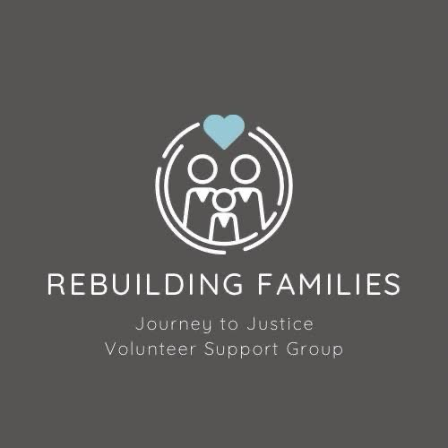

Whistleblower Policy – Volunteer Acknowledgment Summary
Rebuilding Families: Journey to Justice
I confirm that I have read, understood, and agree to abide by the Whistleblower Policy of Rebuilding Families: Journey to Justice. As a volunteer working from home to support individuals falsely accused of safeguarding, I recognize the following core responsibilities:

1. What Constitutes a Whistleblowing Concern
- Misuse or misappropriation of funds
- Breaches of data protection or confidentiality
- Falsification or improper destruction of records
- Abuse of power or harm to vulnerable individuals
- Criminal activity or suspected criminal behavior

2. Reporting Procedure
- Raise concerns promptly to Carrie or Sharon
- Provide details including date(s), involved person(s), and any supporting evidence
- Choose any of the following methods:
📧 Email
📞 Phone
📝 Anonymous reporting form

3. What to Expect After Reporting
- Acknowledgment of your concern within 5 working days
- A fair, confidential, and timely investigation
- Protection from retaliation or victimization if you act in good faith

4. Confidentiality & Data Handling
- All information is treated in line with GDPR and our internal data protection standards
- Only authorized personnel will have access to your disclosure

Volunteer Declaration & Signature
I hereby acknowledge that I:
- Have understood the Whistleblower Policy and my responsibility to raise any concerns.
- Will act in good faith and in accordance with the policy.
- Know how to contact Carrie or Sharon if needed.
Volunteer Name (printed) | Signature | Date
Return signed form to:
• Carrie – carrie.rebuilding@familysupportgroup.info
• Sharon – sharon.rebuilding@familysupportgroup.info

