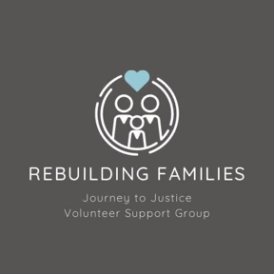

Rebuilding Families

Equality, Diversity, and Inclusion (EDI) Policy

Journey to Justice – Volunteer Support Group

1. Policy Statement

Rebuilding Families is committed to fostering a culture of equality, diversity, and inclusion (EDI) in everything we do. As a small volunteer-led organisation supporting vulnerable families, we value the unique experiences, identities, and backgrounds of every person we work with. We aim to create an inclusive and respectful environment where everyone—volunteers, families, and partners—is treated with fairness and dignity.

We oppose all forms of discrimination and are dedicated to promoting opportunity, reducing inequality, and ensuring equitable access to our support services.

2. Scope

This policy applies to:
- All volunteers, trustees, and anyone acting on behalf of Rebuilding Families
- All clients, families, and individuals we support
- All activities—whether remote, in-person, or administrative

3. Our EDI Commitments

We commit to:
- Promoting equality of opportunity for all, regardless of age, race, ethnicity, disability, gender, gender identity, religion, sexual orientation, or socioeconomic background
- Recognising and celebrating the diversity of the people we support and work with
- Creating an inclusive environment where everyone feels safe, welcomed, and valued
- Making reasonable adjustments to remove barriers for people with disabilities or additional needs
- Using inclusive, accessible language and materials in all communications
- Providing training and support to volunteers on inclusive practices

4. Supporting Vulnerable and Diverse Families

As many families we support are in vulnerable circumstances, we are especially committed to:
- Meeting them where they are—culturally, emotionally, and practically
- Respecting and acknowledging lived experiences and identity
- Offering flexible communication and meeting options to ensure access and comfort
- Avoiding judgment, bias, or stereotyping of any kind

5. Responsibilities of Volunteers

Volunteers are expected to:
- Treat all clients, colleagues, and communities with respect
- Avoid discriminatory language, assumptions, or behaviour
- Report any incidents of discrimination, exclusion, or bias they witness or experience
- Promote inclusive practice in every interaction
- Commit to continuous learning about equality, diversity, and inclusion

6. Reporting and Addressing Discrimination

Rebuilding Families takes all reports of discrimination, harassment, or exclusion seriously.
Volunteers and clients can report concerns to Carrie W or Sharon T in confidence.

All reports will be:
- Handled fairly and sensitively
- Logged confidentially
- Investigated appropriately, with actions taken if necessary

7. Monitoring and Review

We will review this policy annually to ensure it reflects current best practice and meets the needs of those we support. We welcome feedback from volunteers and service users to help us continue improving our EDI work.

Date of Approval: 27.05.2025
Next Review Due: 27.05.2026
Approved By: Carrie W and Sharon T
📧 sharon.rebuilding@familysupportgroup.info
📧 carrie.rebuilding@familysupportgroup.info

