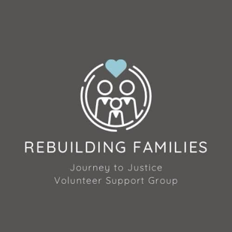

Rebuilding Families GDPR Data Protection Procedure

Rebuilding Families – Journey to Justice

Effective Date: 27.05.2025
Purpose:
To ensure that all personal data handled by Rebuilding Families – Journey to Justice is processed in compliance with the General Data Protection Regulation (GDPR) through clear and consistent procedures.

1. Data Collection Procedure

Who: Volunteer coordinators, event organisers
How:
- Collect only the minimum necessary personal data (e.g., name, email, emergency contact).
- Use paper forms or digital forms that are clearly marked with a privacy notice.
- Obtain explicit consent for any sensitive data (e.g., medical information, photos).
- Keep all forms secure until they are entered into a digital system.

2. Consent Management

Who: Data Protection Contact or lead organiser
How:
- Ensure all consent is freely given, specific, informed, and documented.
- Use checkboxes or signatures to confirm consent.
- Store a record of the consent with a date and context (e.g., “Photo consent for community event”).
- Allow individuals to withdraw consent at any time by emailing [Data Protection Contact Email].

3. Data Storage and Access

Who: Designated group members only
How:
- Store digital files in secure, password-protected systems (e.g., encrypted cloud storage).
- Store paper records in a locked file cabinet or secure space.
- Limit access to personal data to only those who need it for their role.
- Keep a record of who has access to what data.

4. Data Sharing

Who: Coordinators and event organisers
How:
- Do not share data unless absolutely necessary for safety or organising events.
- Only share the minimum required information (e.g., dietary needs for a caterer).
- Ensure third parties (e.g., venue managers) are GDPR-compliant before sharing data.
- Never share data for marketing or commercial purposes.

5. Data Retention and Deletion

Who: Data Protection Contact or designated administrator
How:
- Retain volunteer data only as long as needed (typically 2 years from last involvement).
- Delete or destroy emergency contact info after each event unless otherwise justified.
- Delete health data immediately after the reason for collection no longer applies.
- Shred paper documents when no longer needed and use secure delete tools for digital files.

6. Responding to Data Subject Requests

Who: Data Protection Contact
How:
- Respond to access, correction, or deletion requests within 30 days.
- Confirm the identity of the requester before providing data.
- Document all requests and responses.
- If a request is complex, inform the data subject of any delay (within the 30-day limit).

7. Data Breach Management

Who: All volunteers must report; Data Protection Contact manages response
How:
- Immediately report any loss, theft, or unauthorised access to data to the Data Protection Contact.
- Assess the breach and determine if it needs to be reported to the Information Commissioner’s Office (ICO) within 72 hours.
- Inform affected individuals if there is a high risk to their rights and freedoms.
- Record all details in the breach log.

8. Training and Awareness

Who: All members and volunteers
How:
- Provide a short briefing or guide on GDPR responsibilities during onboarding.
- Review this procedure annually or when roles change.
- Keep records of training or briefings provided.

9. Annual Review

Who: Creator and Facilitator Carrie W & Sharon T
How:
- Review this procedure annually or after any incident.
- Update as needed to reflect changes in practice or legal requirements.

Document Owner: Creator and Facilitator Carrie W & Sharon T
Next Review Date: 27.05.2025

