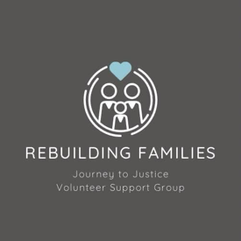

Rebuilding Families

Environmental Policy

Journey to Justice – Volunteer Support Group

1. Policy Statement

Rebuilding Families is committed to minimising its environmental impact and promoting sustainability in all areas of our work. Although we are a small nonprofit with volunteers working primarily from home, we recognise our responsibility to contribute to a healthier environment for the families and communities we support.

2. Scope

This policy applies to all volunteers and activities carried out on behalf of Rebuilding Families, including work from home, online communications, in-person meetings, and community engagement.

3. Key Principles

We will aim to:
- Use resources efficiently and avoid unnecessary waste
- Promote paperless communication wherever possible
- Encourage energy conservation when working from home
- Choose meeting spaces that are local, accessible, and energy efficient
- Reuse and recycle materials when practical
- Promote environmental awareness among volunteers and clients

4. Working From Home

Volunteers will be encouraged to:
- Turn off lights and electronics when not in use
- Limit printing and use digital alternatives
- Use reusable or recyclable office materials
- Keep heating and energy use efficient

5. Face-to-Face Meetings
- Encourage public transport, walking, or car-sharing when safe and possible
- Choose meeting venues with environmentally responsible policies where practical
- Avoid the use of single-use plastics or materials during sessions

6. Digital Practices
- Use cloud-based platforms and email instead of paper
- Store documents digitally in secure, eco-friendly formats
- Encourage sustainable online habits (e.g. avoid unnecessary large file transfers)

7. Encouraging Clients and Partners

While supporting families, we will gently promote eco-awareness by:
- Sharing resources on reducing household waste or energy use (when appropriate)
- Modelling sustainable habits through our own practices
- Respecting the unique challenges and capacities of vulnerable families

8. Policy Review and Development

This policy will be reviewed annually or earlier if environmental guidance or operational activities change. All volunteers will be invited to suggest improvements.

Date of Approval: 27.05.2025
Next Review Due: 27.05.2026
Approved By: Carrie W and Sharon T
📧 sharon.rebuilding@familysupportgroup.info
📧 carrie.rebuilding@familysupportgroup.info

